Team Meeting

**Google meet link**: <https://meet.google.com/ocw-qxov-bbn?hs=151>

**Day 1** (03/05/2021)

**Meeting Agendas:** Project Charter Completion

**Day 2** (04/05/2021) – Time (**11:37 to 1:23pm**)

**Meeting Agendas:** Discussed Team Contract.

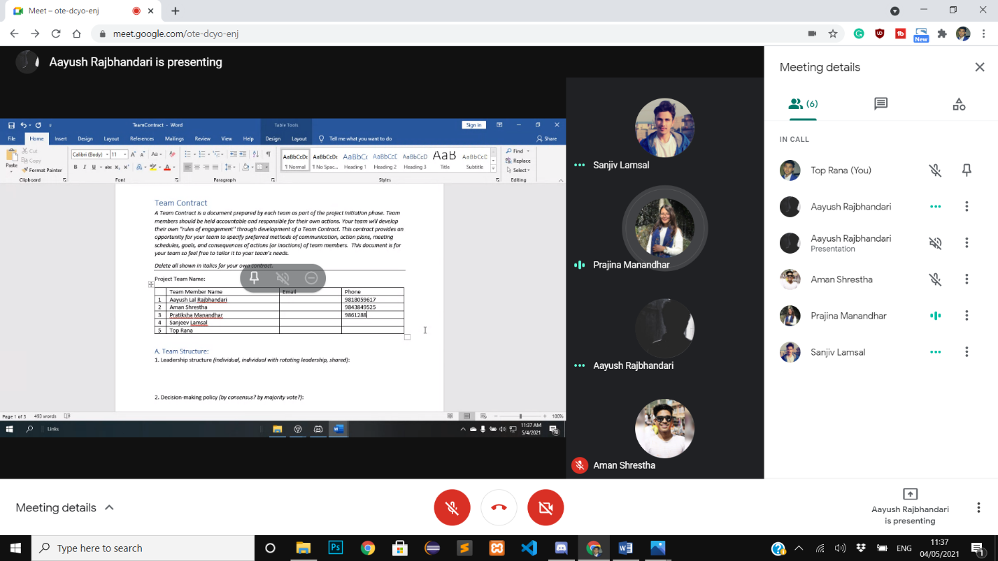

**Day 3 (11/05/2021)** – Time (**6:33 to 7:34 pm**)

**Meeting Agendas:** Finalised Skill Audit.

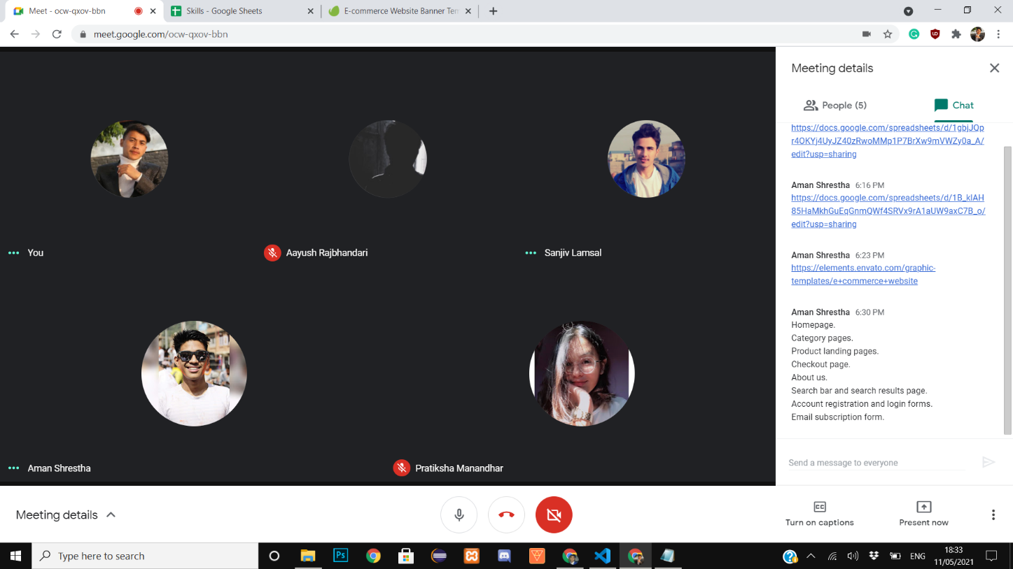

**Day 4 (18/05/2021)** – Time (**6:33 to 7:34 pm**)

**Meeting Agenda:** Discussed ERD, EERD, Composite, Logical Table

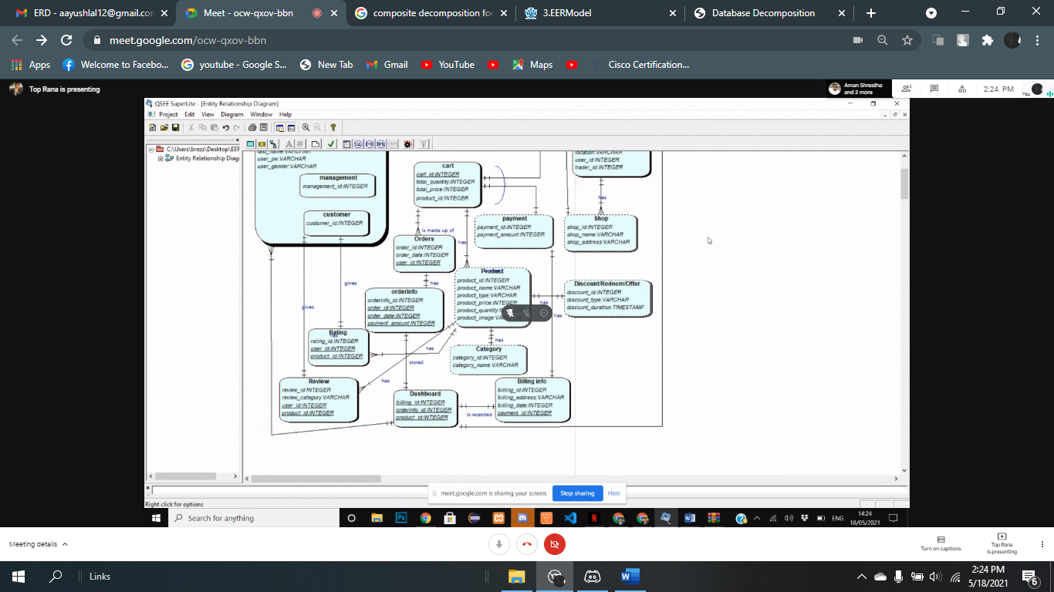

**Day 5 (27/05/2021)** – Time (**12:30 to 1:57pm**)

**Meeting Agenda:** Finalised use case diagram

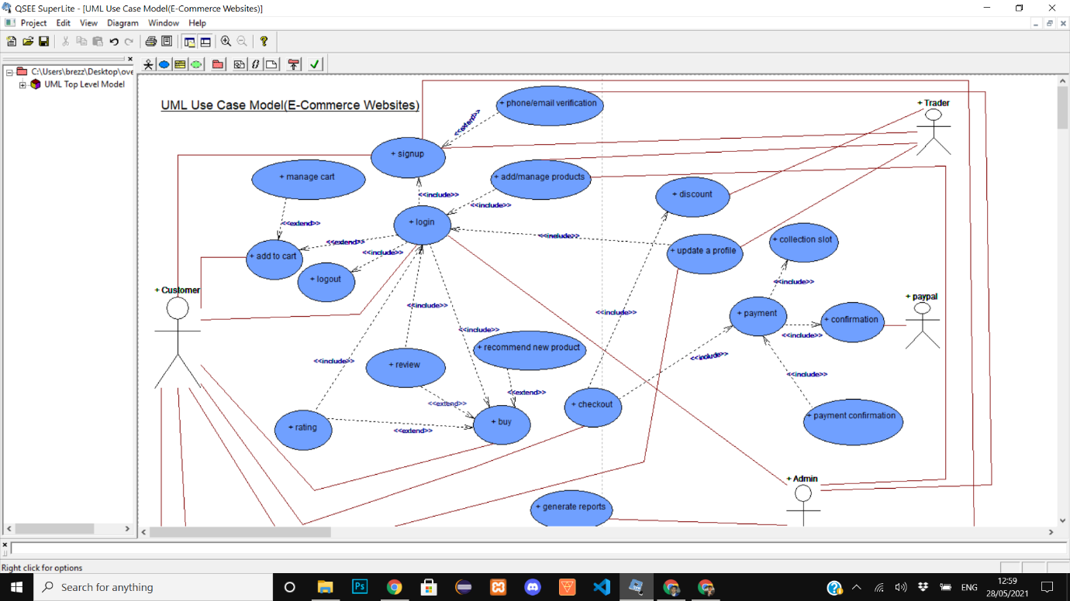

**Day 6 (26/05/2021)** – Time (**12:30 to 2:23pm**)

**Meeting Agenda:** FinalisedWireframe between team members

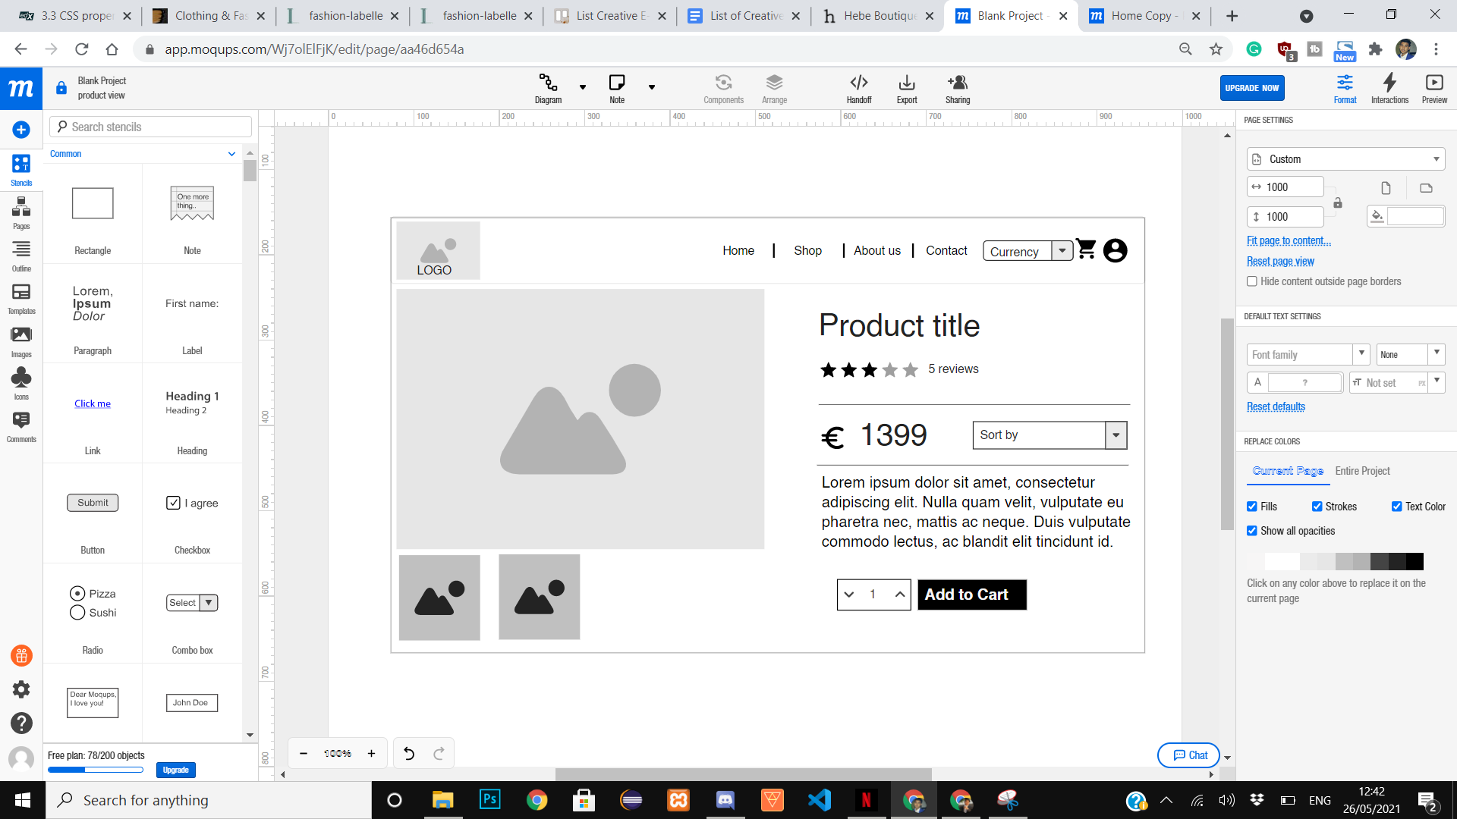

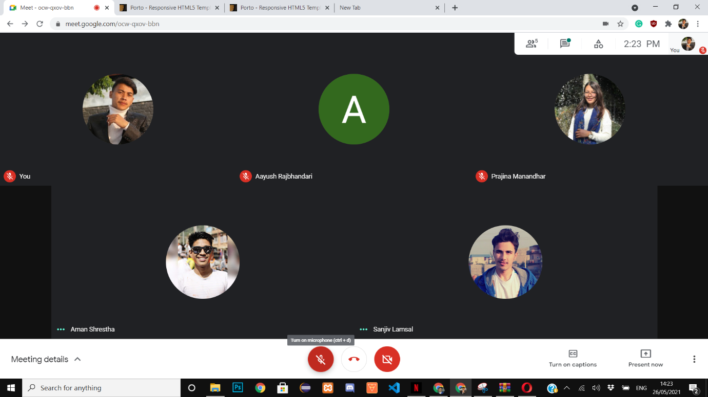

**Day 7 (31/05/2021)** – Time (**1:03 to 2:30pm**)

**Meeting Agenda: MOSCOW**

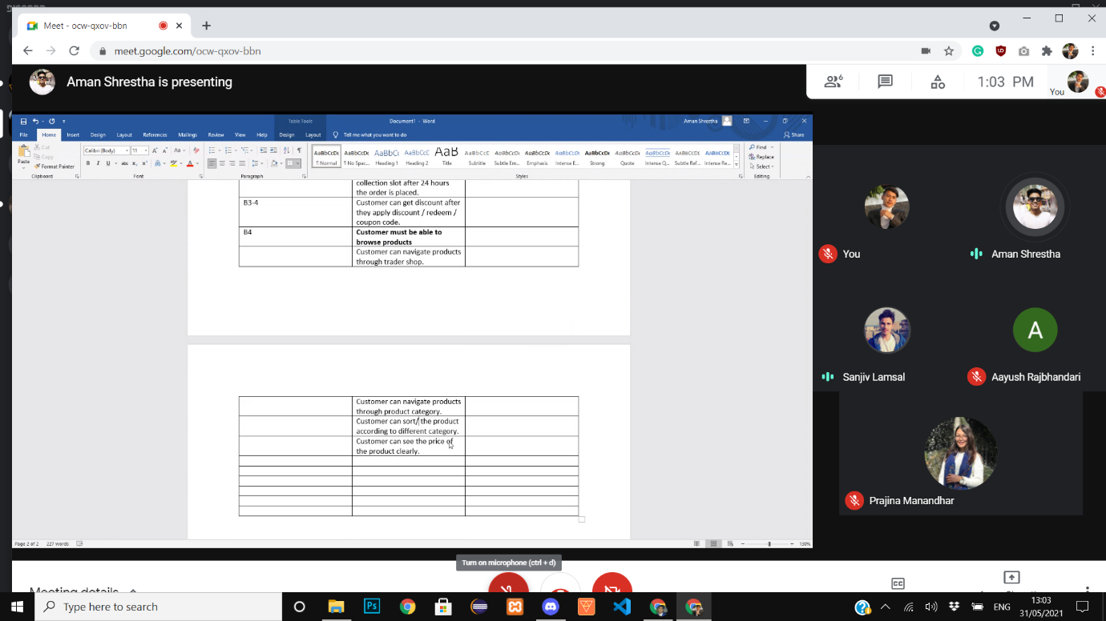

**Day 8 (11/06/2021)**

**Meeting Agenda: WIP Presentation**

